Assessment 1: Big Data HDFS Assessment

SRUTHY SUJI
23AD140
AI-DS C

- Create a directory /hadoop/hdfs/ in HDFS
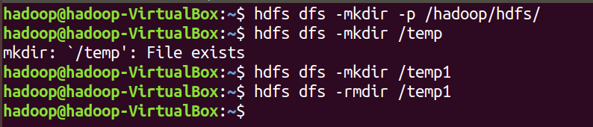

- Create a temp directory in hdfs /temp and run HDFS command to delete “temp” directory.

- Command to list recursively all files in hadoop directory and all subdirectories in hadoop directory
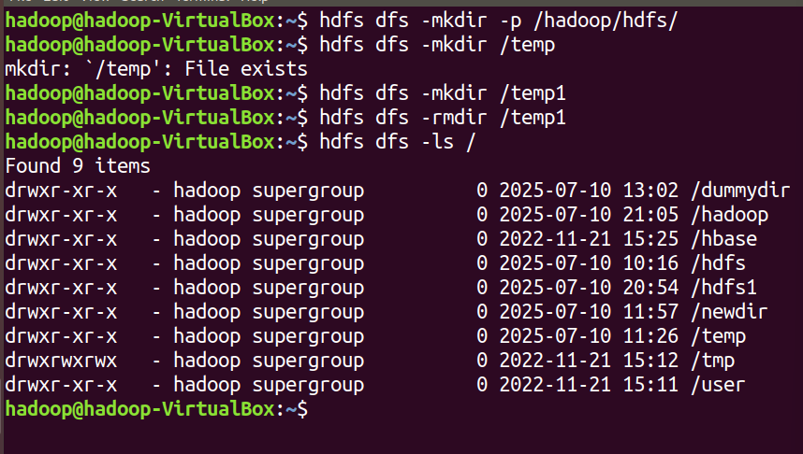

- List all the directory inside /hadoop/hdfs/ directory which starts with 'dir'.
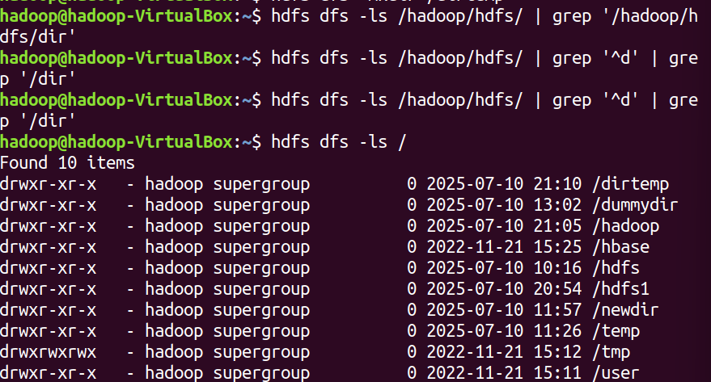

- Create a temp.txt file. Copies this file from local file system to HDFS
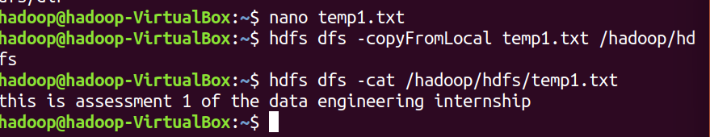

- Command to move from local directory source to Hadoop directory.
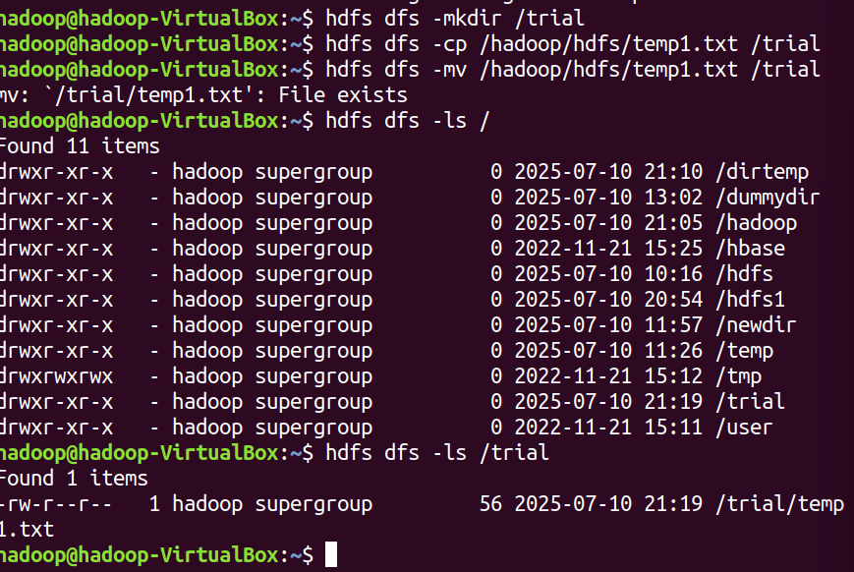

- Display the content of the HDFS file test on your /user/hadoop2 directory.
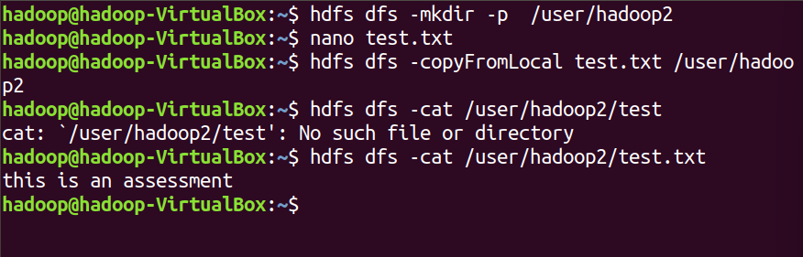

- Upload a compressed file restaurant_dataset.zip to HDFS directory /restautant and then unzip it inside HDFS (not locally). Is it possible? Justify your answer with commands or explanation.
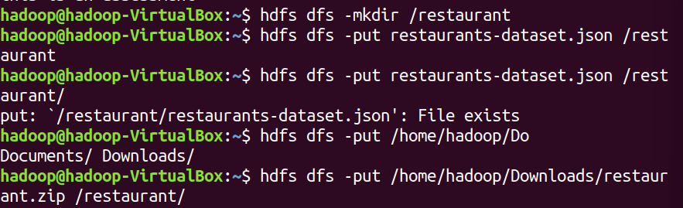

‘

i) Append the content of a local file test1.txt to a hdfs file test2.txt.
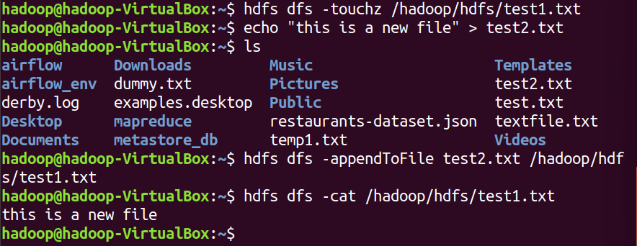

J)Show the capacity, free and used space of the filesystem
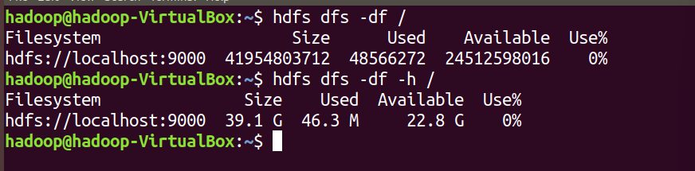

k) Shows the capacity, free and used space of the filesystem. Add parameter Formats the sizes of files in a human-readable fashion.

l) Show the amount of space, in bytes, used by the files that match the specified file pattern.
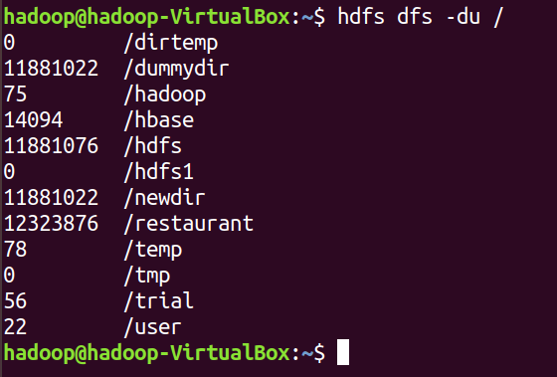

m) Show the amount of space, in bytes, used by the files that match the specified file pattern. Formats the sizes of files in a human-readable fashion.
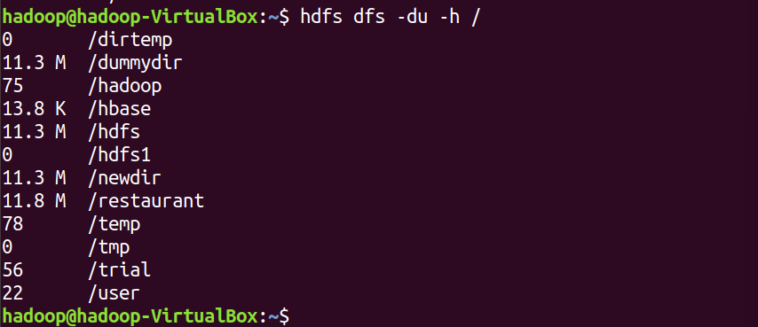

n) Check the health of the Hadoop file system.
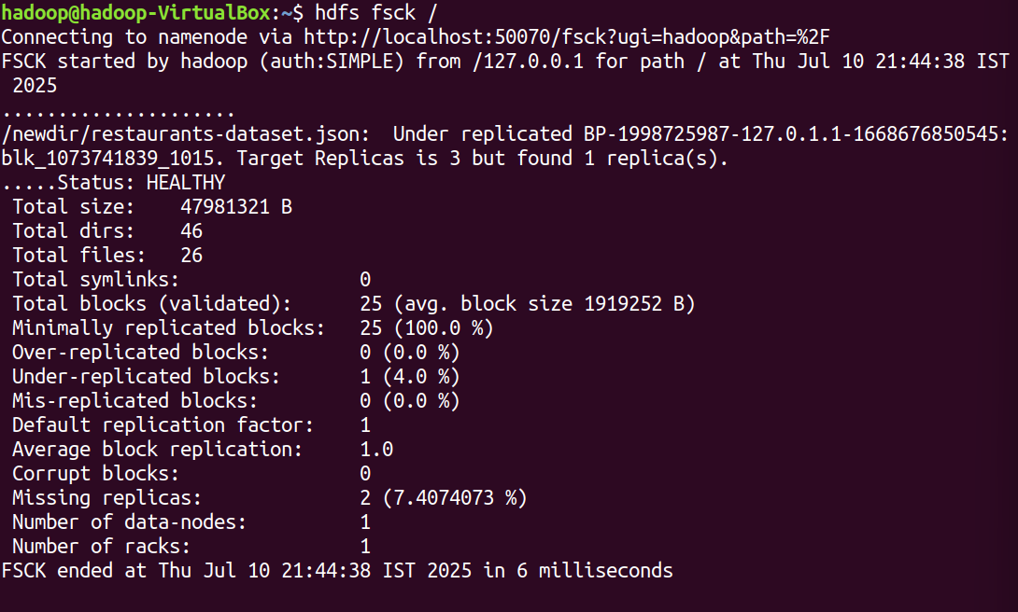

o) Create a file named hdfstest.txt and change it number of replications to 3.

p) Write command to display number of replicas for hdfstest.txt file.


q) Write command to Display the status of file “hdfstest.txt” like block size, filesize in bytes
r) Write HDFS command to change file permission from rw – r – r to rwx-rw-x for hdfstest.txt.

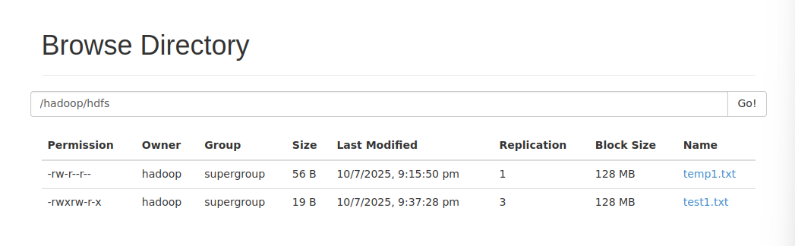

s) Find all files with .csv extenstion and delete all empty files (0 bytes) in HDFS under /hadoop/.
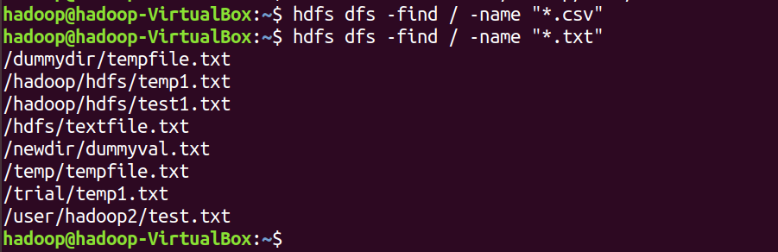

t) Create a snapshot-enabled directory /snapshotdir/. Take a snapshot and delete the snapshot.
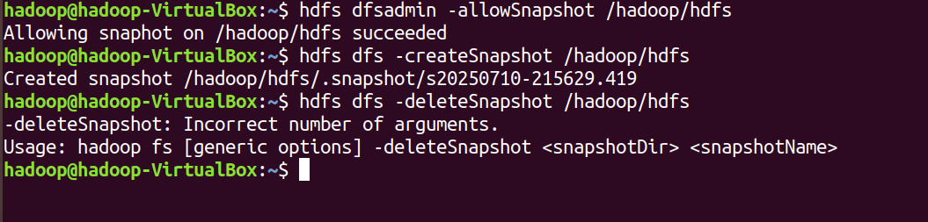

u) Execute a command to generate checksum for an HDFS file hdfstest.txt and explain its purpose.
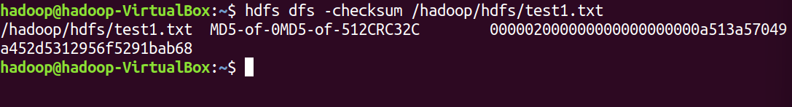

v) Change the blocksize of already existing file in /hadoop/hdfs directory. Is it possible? Justify your answer with commands or explanation.

=> it is Not possible to change the block size directly of an already uploaded file in HDFS

Assessment 2 - Employee Attrition Analysis

Create database “hremployeedb” and create a table “hremp”. Insert all records from file.

- Create database

CREATE DATABASE hremployeedb;
USE hremployeedb;

2.create table
CREATE TABLE hremp (
Attrition VARCHAR(10),
Business_Travel VARCHAR(50),
CF_age_band VARCHAR(50),
CF_attrition_label VARCHAR(50),
Department VARCHAR(50),
Education_Field VARCHAR(50),
emp_no VARCHAR(20),
Employee_Number INT,
Gender VARCHAR(10),
Job_Role VARCHAR(50),
Marital_Status VARCHAR(20),
Over_Time VARCHAR(10),
Over18 VARCHAR(5),
Training_Times_Last_Year INT,
Age INT,
CF_current_Employee VARCHAR(5),
Daily_Rate INT,
Distance_From_Home INT,
Education INT,
Employee_Count INT,
Environment_Satisfaction INT,
Hourly_Rate INT,
Job_Involvement INT,
Job_Level INT,
Job_Satisfaction INT,
Monthly_Income INT,
Monthly_Rate INT,
Num_Companies_Worked INT,
Percent_Salary_Hike INT,
Performance_Rating INT,
Relationship_Satisfaction INT,
Standard_Hours INT,
Stock_Option_Level INT,
Total_Working_Years INT,
Work_Life_Balance INT,
Years_At_Company INT,
Years_In_Current_Role INT,
Years_Since_Last_Promotion INT,
Years_With_Curr_Manager INT
);

- Calculate the cumulative sum of total working years for each department

SELECT Department, `Employee Number`,`Total Working Years`, SUM(`Total Working Years`) OVER (PARTITION BY Department ORDER BY `Employee Number`) AS Cumulative_Total_Working_Years FROM hremp;
